Configuration and Installation Document for Cognitive Nao Robots



Project Lead: Phil Watson
Authors:
Shoaib Bilal
Andreas Maude

Document Control
ver | Date | Author | Comments
1.0 | 24/05/2016 | Andreas Maude | Doc creation for handover.
1.1 | 30/05/2016 | Andreas Maude
1.2 | 18/7/2016 | Andreas Maude

Special Thanks To:
Hidemasa Muta
Ann Cho

Contents
Document Control 2
1 Getting Started with Cognitive Nao robots 4
1.1 Registering with Aldebaran 4
1.2 Minimum Software Requirements 4
1.3 Equipment 5
1.4 Taking the Nao out of the box 5
1.5 Turning the Robot On 5
1.6 Connecting to the Robot 6
1.6.1 Connecting the first time 6
1.6.2 Setting Up a WiFi Network to Use Nao Wirelessly 7
2 Basics: Choregraphe 8
2.1 Connecting to the Robot 8
3 Advanced Use of the Nao 9
4 Appendix 10
4.1 System Requirements 10
4.1.1 Hardware 10
4.1.2 Supported Operating Systems 10

Getting Started

Registering with Aldebaran
Before you download any of your software, register yourself on the Aldebaran website. This will make retrieving some of the software much easier.
- Go to Aldebaran Website: https://www.ald.softbankrobotics.com/en
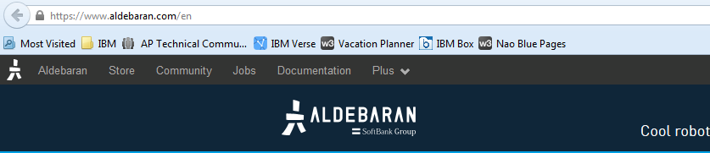
- Click Community

- Click Developers
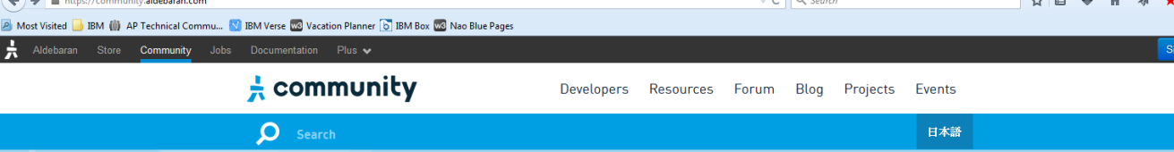
- Click Join
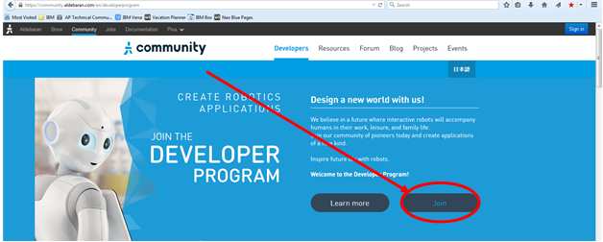
- Click sign in and follow the prompts to register an account
  - Country: America
  - Use: Professional

Minimum Software Requirements
For helpful documentation on all the software listed below that is required to run your Nao, see Documentation. Essential software required is listed below.
- Choregraphe – Download link
  - Choregraphe is the Integrated Development Environment (IDE) for Nao robots. It is simple to use and has an intuitive graphical interface.
- Python 2.7 – Download link
  - IMPORTANT NOTE: You must use Python 2.7. Python 3+ is not supported.
  - Nao’s internal packages are written in C++, but these are accessed in an easy way using Python code. These are some useful Python add-ons to install:
    - pip (automatically accompanies Python 2.7)
    - python image library (pil) – Download link
    - Python-friendly text editor (e.g. Atom – Download link)
- NaoQi – Download link
  - NaoQi is Nao’s operating system (OS). You must have NaoQi installed to use Python to communicate with the robot.

Equipment
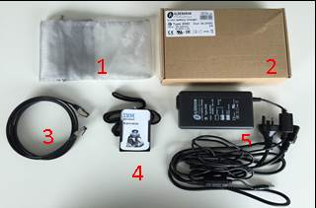
- Grey bag for networking cable
- Storage box for power cables
- Networking cable
- NAO’S I.D. Badge (only if previously ordered)
- Power cable

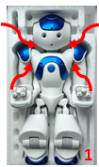
Taking the Nao out of the box
- Gently lift Nao from under each arm and above each shoulder, lifting the torso and head out first, followed by the legs. NB: Support NAO’s head when lifting it out of the box.
- Lay NAO on its back on a flat and stable surface at least 60cm from any edges.
- If there are elastic bands around the fingers, remove elastic bands from each hand placing them back in the polystyrene box. Note: elastic bands are useful for protecting the delicate fingers and should be used when storing the robot.

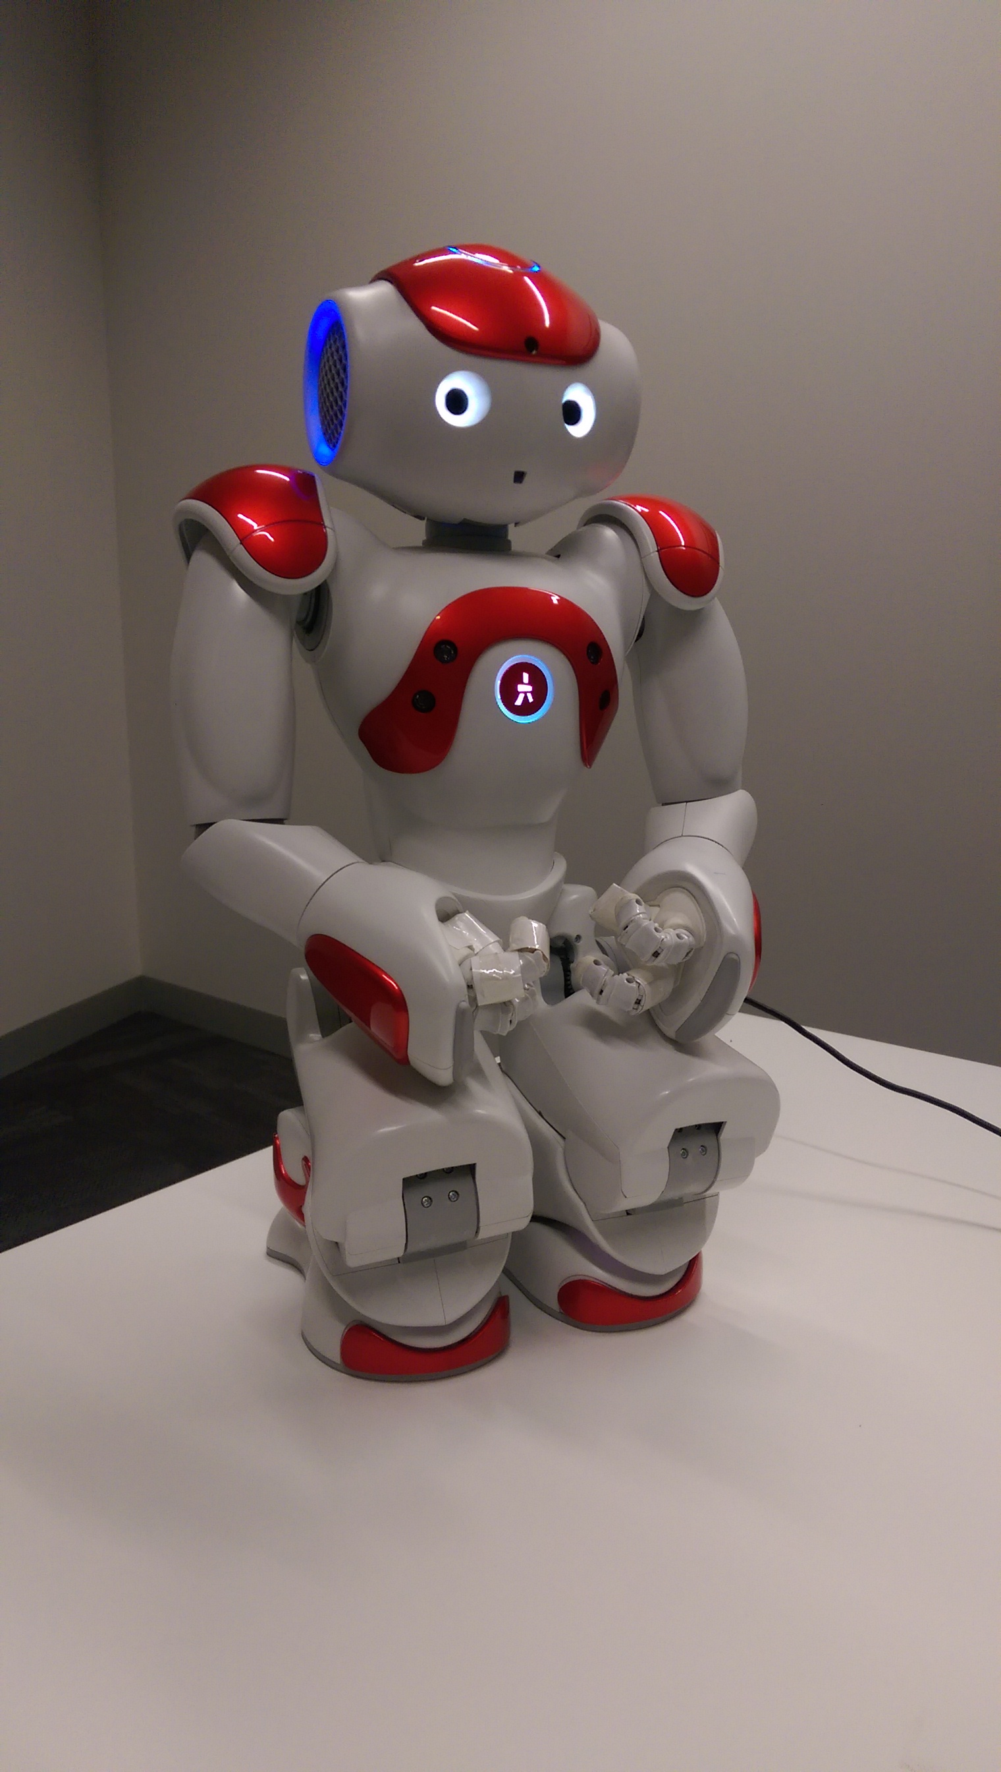
Turning the Robot On
Figure 1 - Starting position
First, ensure that the robot is in an upright, stable position (see Error: Reference source not found), and that the battery has sufficient charge. If you are unsure how much charge the battery has, keep the robot plugged in to the power source while turning on. The charging port is located in the middle of the back of the robot.
To turn the robot on, hold the chest button for ~2 seconds. The lights will turn on. Start-up takes some time. The process is complete when the robot utters its start-up sound, “gnouk, gnouk”, and stands up.

Connecting to the Robot

Connecting the first time
The first time you connect to your robot you will have to use the Ethernet cable. The Ethernet port for the robot is in the back of the head:
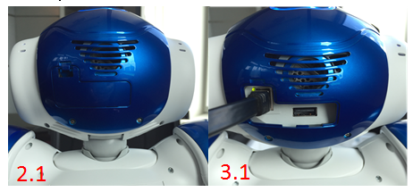
- Connect the Ethernet cable to the Nao robot and to your computer. The robot can take up to five minutes to connect.
- Press the chest button once; the robot will tell you its IP address. If it has not yet connected, it will utter “I cannot connect to the network”. If this is the case, wait a few more seconds and try again.
- If you attempt step 2 three times, NAO will repeat the IP address very slowly in order for the user to hear it clearly.
Once you have it, type the IP address into your browser to connect to the robot webpage (Figure 1). The username and password are “nao”.
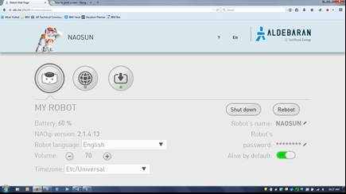
Network settings
Figure 1 - Robot webpage

Configuring the Nao
On the first time connecting to the Nao, you will be prompted to start the configuration wizard. Follow the prompts to set up the language, name, and password of your Nao robot. If required, there is helpful documentation to guide you.

Setting Up a WiFi Network to Use Nao Wirelessly
After you have connected for the first time, you can return to the robot web page to use some basic controls for the robot, such as volume, and setting up new wireless networks. To connect Nao to a wireless network,
- Click the network settings button (see Figure 1),
- In the “Network Settings” page that pops up (Figure 2), click ‘refresh’,
- Click on the desired wireless network and type in the password if required. If successful, it will say “fully connected” below that network,
- You can now remove the Ethernet cable.
Note: once you have removed the Ethernet cable, the Nao will switch networks to the newly configured wireless one. Its IP address will change, and you will have to press the chest button again to hear the new IP address. With the new IP address, you can connect to the robot webpage again as before to confirm that the robot has connected to the new network. Ensure that your computer is connected to the same network as the Nao.
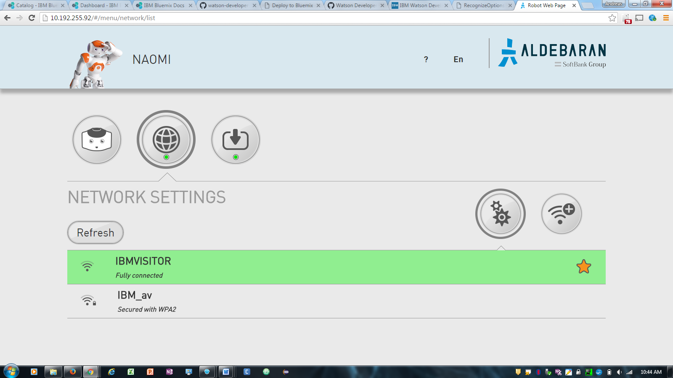
Figure 2 - Network settings page
Security Issues: currently, Nao robots cannot connect to the IBM network due to security certificate issues. A good solution is to connect to the IBM Visitor network. However, in many regions, the IBM visitor network is not strong enough to maintain a good connection to the Nao. In such regions, either remain connected through the Ethernet cable, or use a HotSpot.
Once you have successfully connected the Nao to the correct network, the Nao remembers that network. In the future, it should automatically connect to that network, without requiring you to use the Ethernet cable.

Installing Choregraphe

Basics: Choregraphe

Connecting to the Robot
At this stage, it is assumed that Choregraphe is installed, that you have connected to the robot for the first timeConnecting the first time, and that the robot is connected to a network and has an IP address.
- Launch Choregraphe.
- Obtain the robot’s IP address by pressing the chest button once.
- Press the green ‘connect’ button.
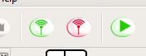
- Click “Use fixed IP/hostname” and enter the robot’s IP address. Ensure that both boxes are ticked and hit “Select”.
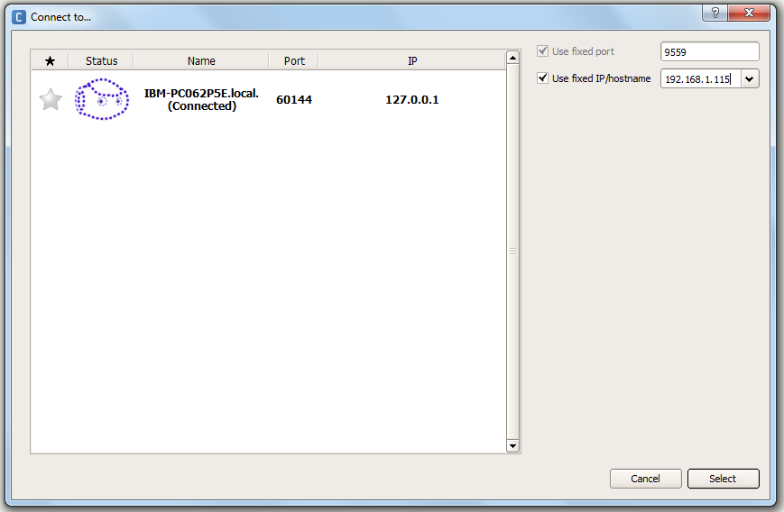
- Check the video monitor to see the Nao’s camera feed and determine if connection was successful.
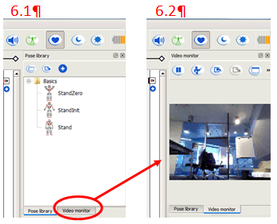

Basic Controls
At this stage, it is assumed that you have launched Choregraphe and are connected to the robot. There are a few key controls available in Choregraphe that are essential for smooth operation of the robot.

Basics: Python
This section deals with the basic commands and communication protocols that you can use to control the robot. It is assumed that you have the relevant Python and NaoQi software installed (see Minimum Software Requirements) and are connected to the robot.

Running Python Code on Command Line
This section will cover only the very basics of running Python scripts through the command line. For more advanced use of Python please consult Python documentation, visit the coding community web pages or investigate learning and training opportunities.

Advanced Use of the Nao
This section deals with the Watson applications that are available

download and install python 2.7. https://www.python.org/downloads/release/python-2711/
install it anywhere but C drive is recommended. add the folder to your environment variables (http://windowsitpro.com/systems-management/how-can-i-add-new-folder-my-system-path) (that's for windows). create a python file (.py extension). use a good text editor (I use atom - https://atom.io/) and write your code in the .py file. run cmd.exe and navigate to the folder with your file in it. type in "python file_name.py" - that runs your code

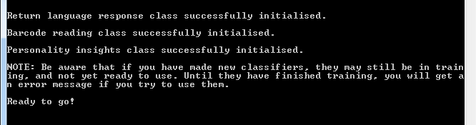

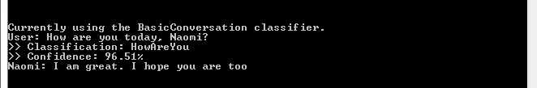

Appendix

System Requirements

Hardware
A computer connected to an open WiFi access point, with:
- 1.5 GHz CPU
- 512 MB RAM
- a certified OpenGL graphics card

Supported Operating Systems

OS | Version
Linux | Ubuntu 12.04 LTS (Precise) and later
Windows | Microsoft Windows XP Service Pack 3,  Microsoft Windows 7 and 8
Mac | Mac OS X version 10.7.1 Lion  Mac OS X version 10.8.3 Mountain Lion

Software Requirements

Bluemix Services

Personality Insights
Documentation
API Reference
Demo

Visual Recognition
Documentation
API Reference
Demo

Conversation
Documentation
API Reference

